Source Code

package travelapplication;

import java.util.\*;

/\*\*

\*

\* @author User

\*/

public class TravelApplication {

/\*\*

\* @param args the command line arguments

\*/

public static void main(String[] args) {

// TODO code application logic here

Scanner scan = new Scanner(System.in);

TravelData[] traveldata = new TravelData[5];

for(int i =0; i<traveldata.length; i++){

try{

System.out.println("Package Title: ");

String Title = scan.nextLine();

System.out.println("Description : ");

String Description = scan.nextLine();

System.out.println("Price for single person: ");

double Price = scan.nextDouble();

System.out.println("Travel duration : ");

double Duration = scan.nextDouble();

scan.nextLine();

traveldata[i] = new TravelData(Title,Description,Price,Duration);

}catch(Exception e){

System.out.println("Invalid"+" \nPlease enter a data again");

main(args);

}

}

System.out.println("\*\*\*\*\*\*\*\*\*\*\*\*\*\*\*\*\*\*\*");

for(int i =0; i<traveldata.length; i++){

System.out.println("Packages title :"+ traveldata[i].getTitle());

System.out.println("Description :"+ traveldata[i].getDescription());

System.out.println("Price for single person : RM "+ traveldata[i].getPrice());

System.out.println("Travel duration :"+ traveldata[i].getDuration());

System.out.println("\*\*\*\*\*\*\*\*\*\*\*\*\*\*\*\*\*\*\*\*\*\*\*");

}

}

}

Class

package travelapplication;

/\*\*

\*

\* @author User

\*/

public class TravelData {

private String Title; String Description;

private double Price; double Duration;

private String Tittle;

TravelData(String Title,String Description,double Price,double Duration){

this.Title = Title;

this.Description = Description;

this.Price = Price;

this.Duration = Duration;

}

String getTitle(){

return Title;

}

String getDescription(){

return Description;

}

double getPrice(){

return Price;

}

double getDuration(){

return Duration;

}

void setPrice(double Price){

this.Title = Title;

}

void setDuration(double Duration){

this.Title = Title;

}

void setDescription(String Description){

this.Tittle = Title;

}

}

Screenshot

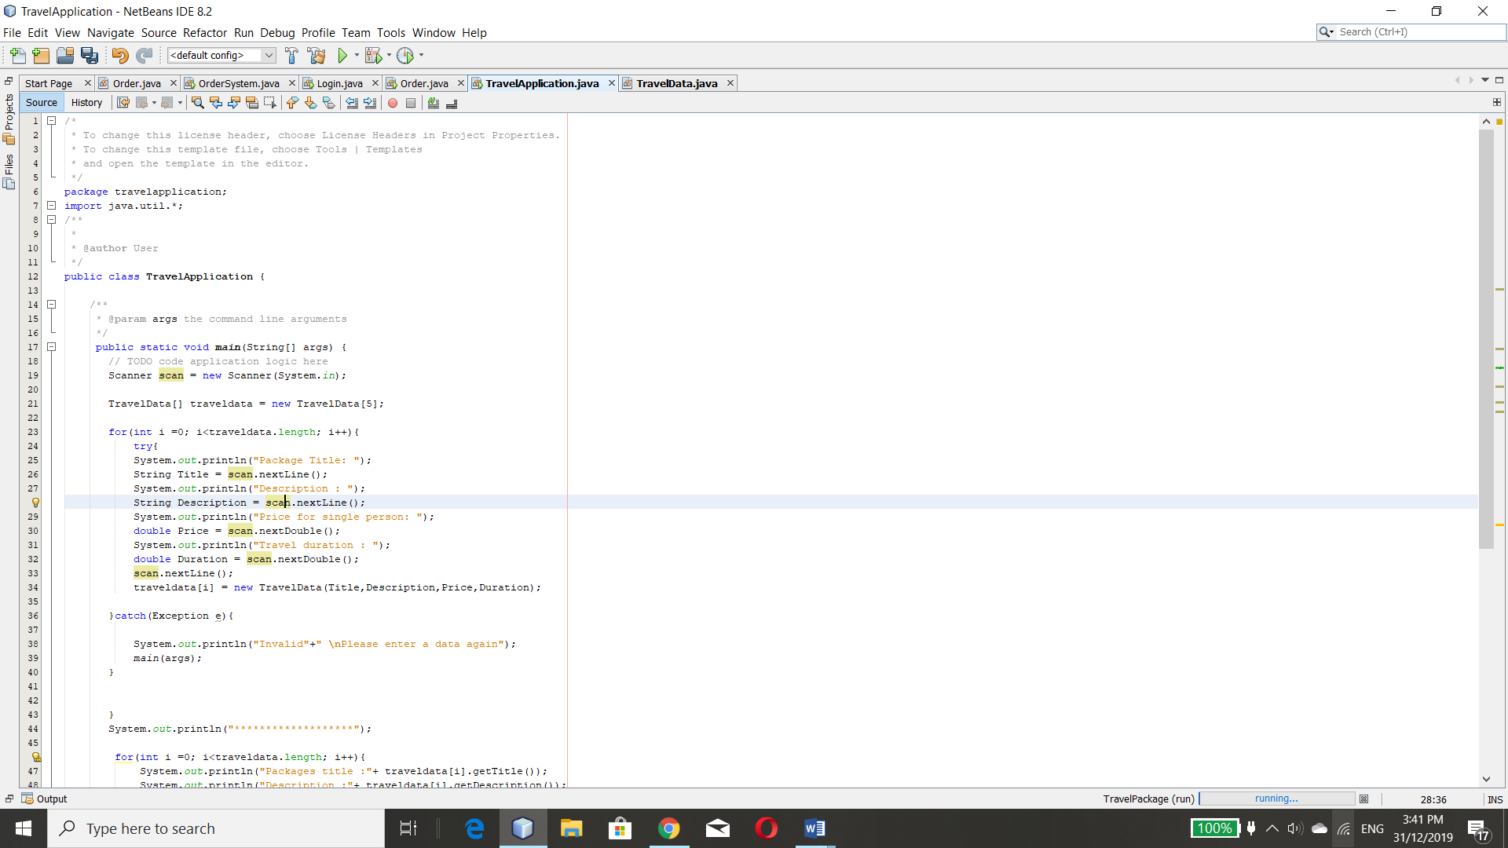

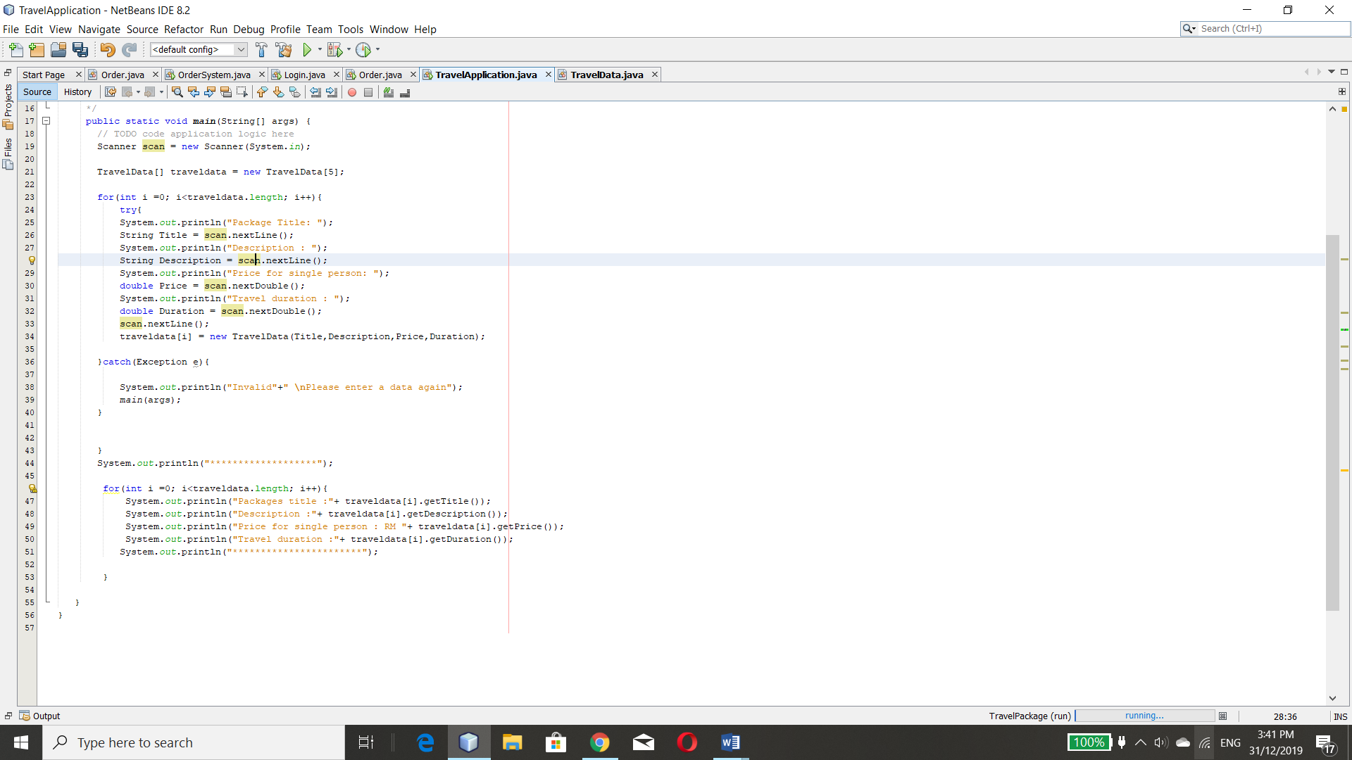

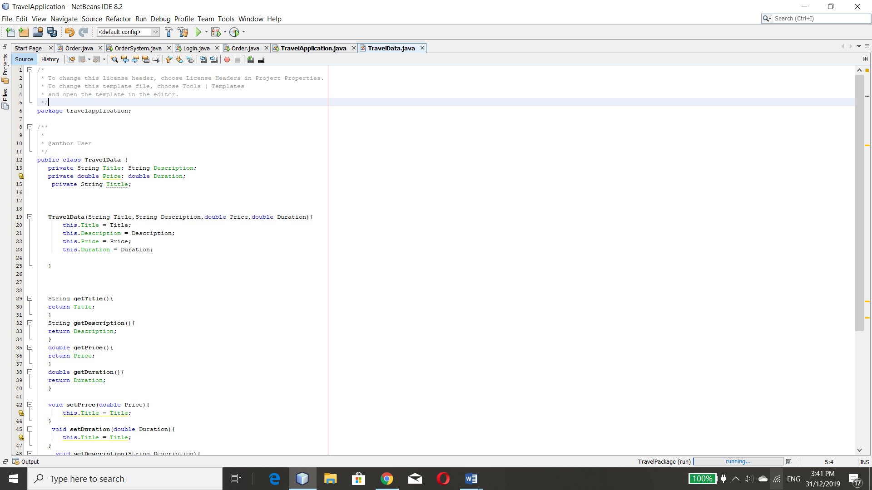

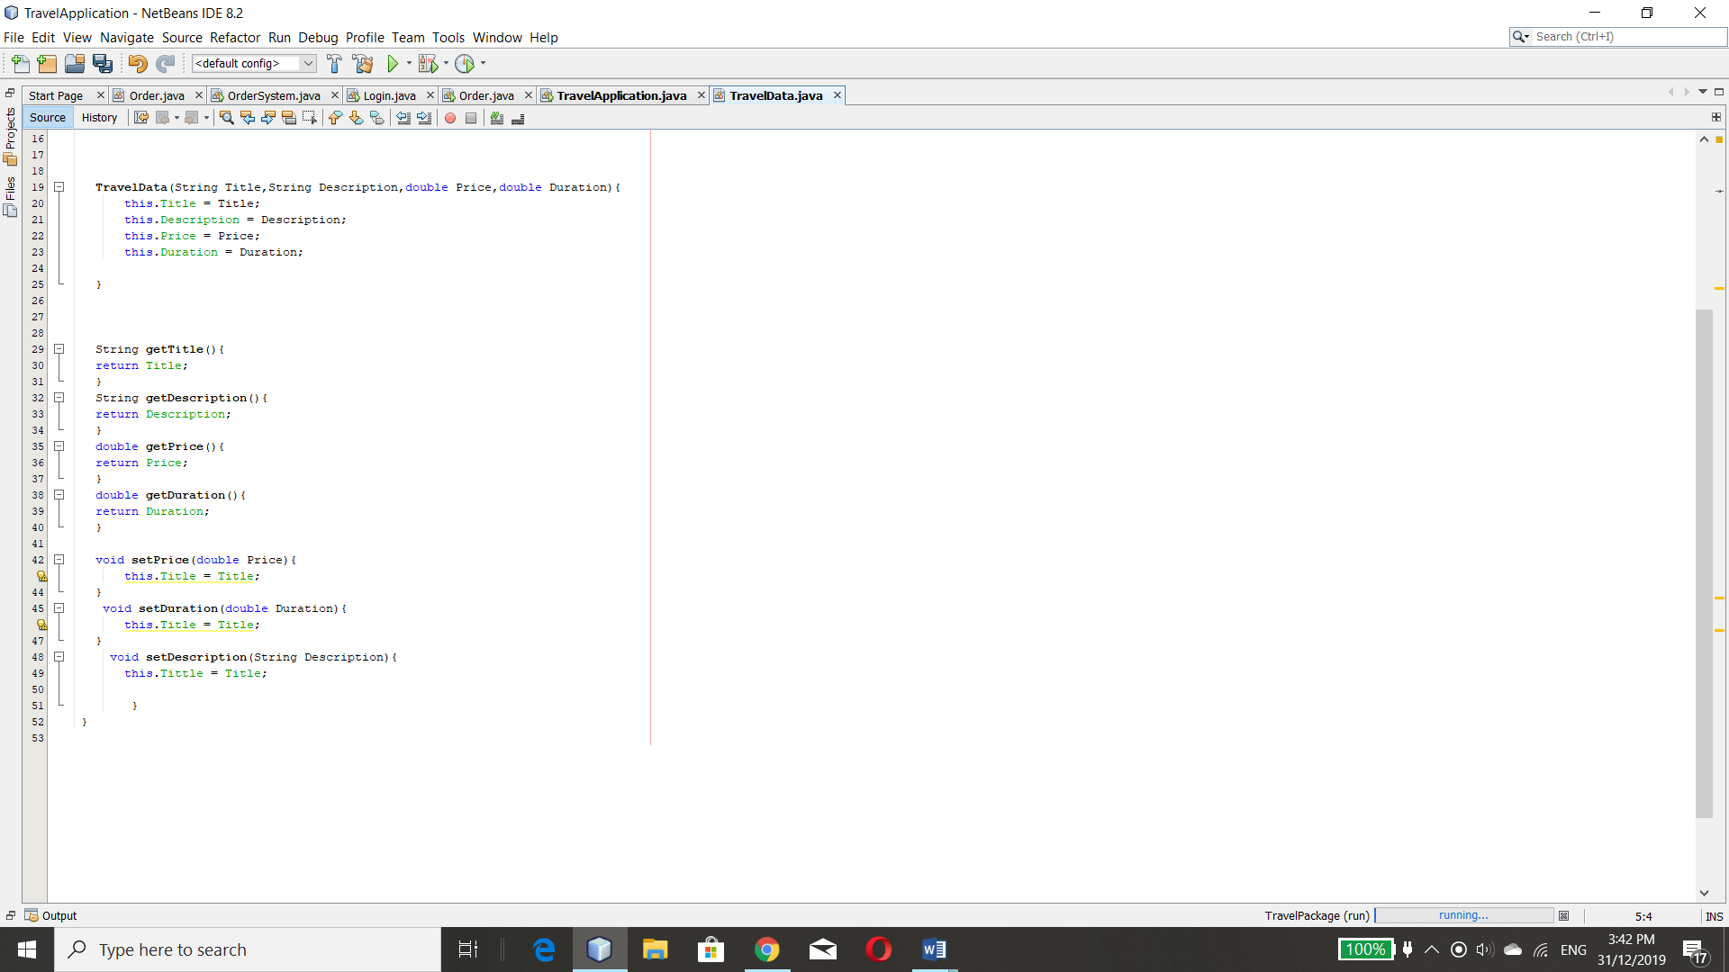

Input

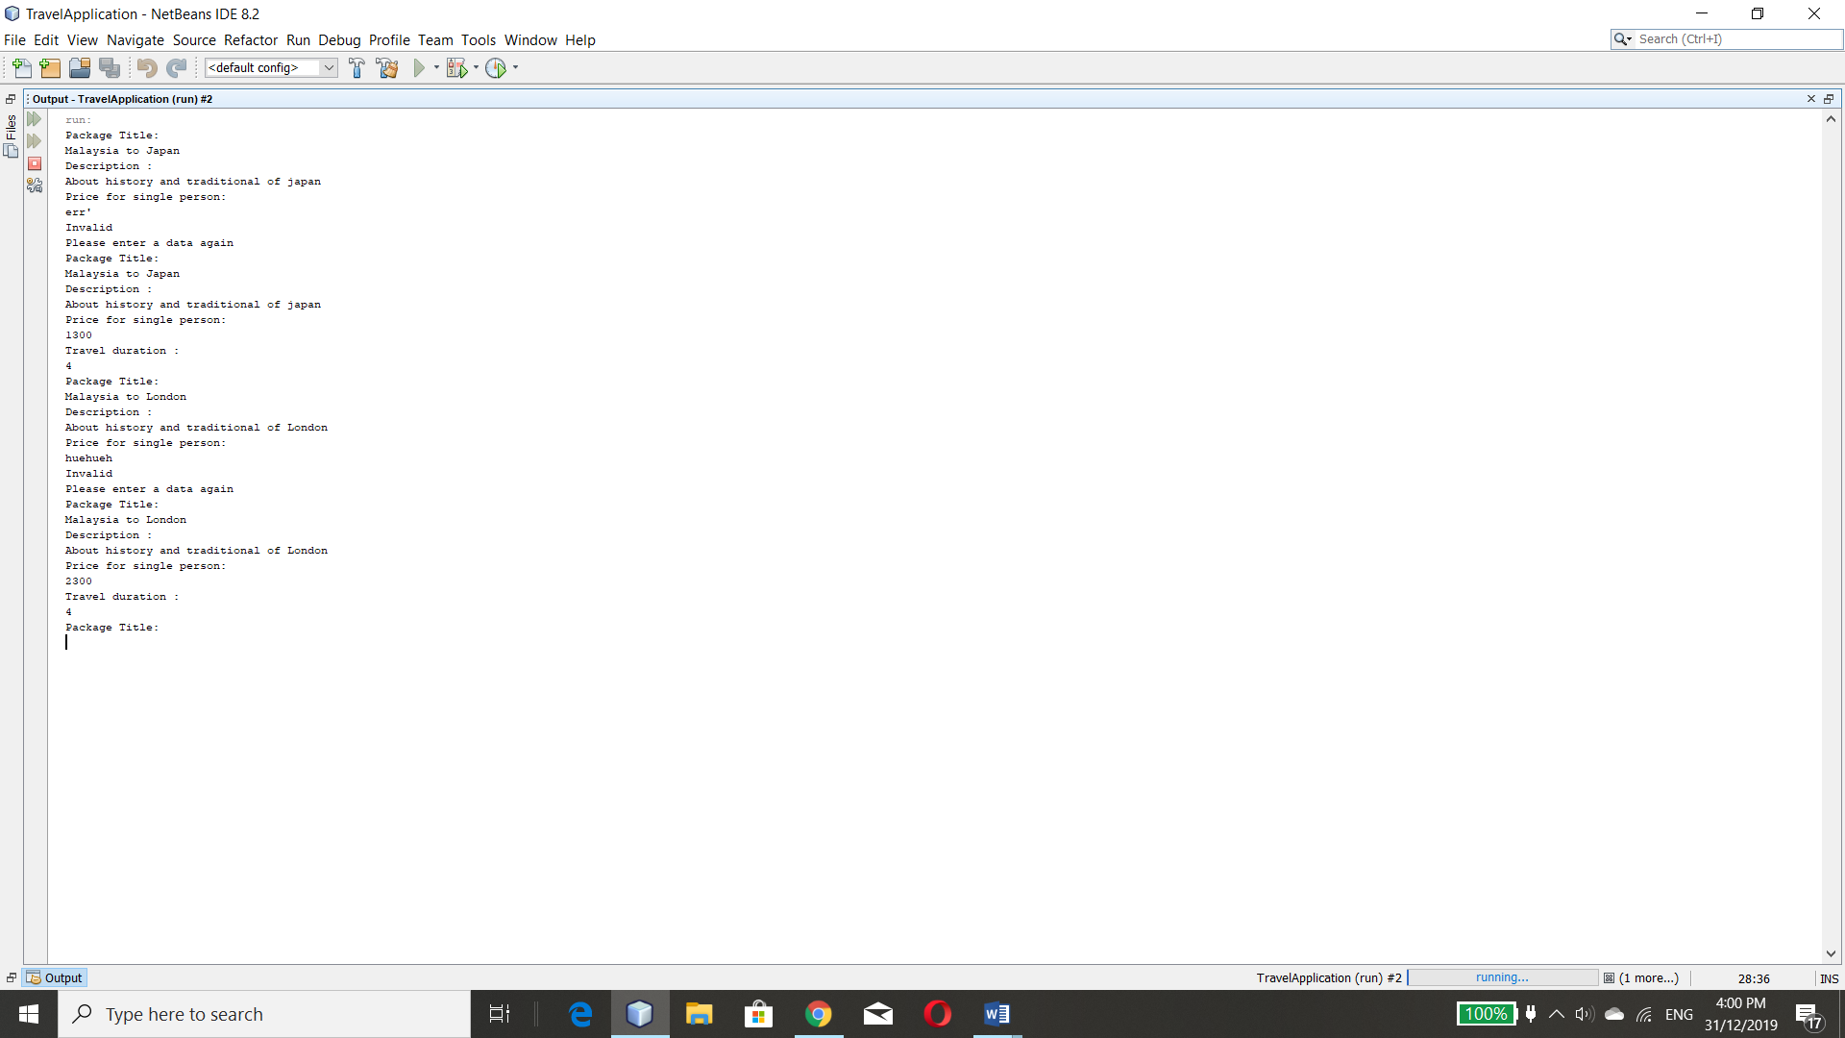

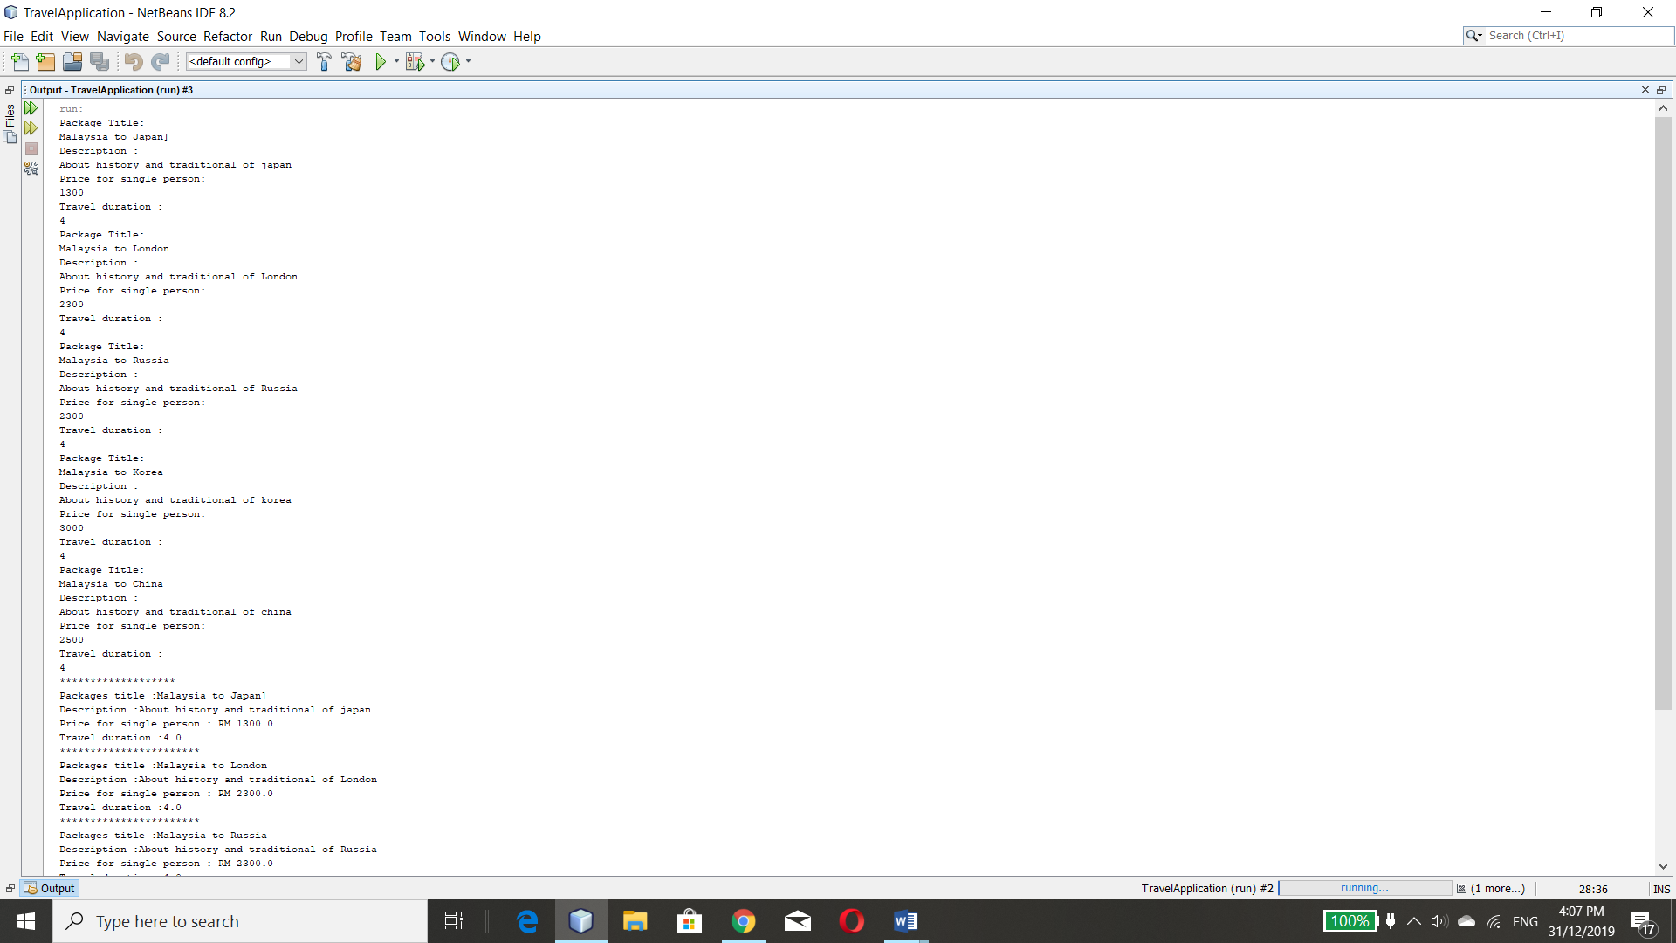

Output

